Cloud Service Ranking and Selection-Particle Swarm

Optimization

Elamathy.V(312214405004)
ME CSE, Semester 3
Mr.Sujaudeen N
Supervisor

Project Review: 2 (20 October 2015) Department of Computer Science and Engineering SSN College of Engineering

1 Abstract

Cloud computing is an Internet based computing, whereby shared configurable re- sources are provided to cloud services consumers as services on demand. As an in- creasing growth of cloud computing, many enterprises provide different cloud ser- vices to cloud service consumer. From cloud services consumers perspective, it is difficult to choose an appropriate cloud service that satisfies their Qos requirements. As requirement of one cloud service consumer will vary from another, hence there is a need for common platform which will register the Service Level Agreement (SLA) of the cloud services provider. Also the ranking of cloud services is to be performed based upon the requirements of the users. We intend to propose a Particle Swarm Optimization, an evolutionary based algorithm that can co-operatively optimize the ranking of cloud services and select suitable service that satisfies almost all require- ment of the consumer. Of course, PSO has computational complexity with respect to the selection process it provides efficient cloud service to the user.

2 Introduction

Cloud computing is a model for enabling ubiquitous, convenient, on-demand net- work access to a shared pool of configurable computing resources that can be rapidly provisioned and released with service provider interaction .It is a new paradigm for delivering on-demand resources for customers through internet. A service is a mech- anism that is capable of providing one or more functionalities, which it is possible to use in compliance with provider defined restrictions and rules and through an in- terface .There are three services models in cloud. They are Software as a service: A software or application that is executing on a vendors infrastructure is recognized as a service provided that the consumer has limited permission to access and the provision is through a thin client or a program interface for sending data and receiving results.

The consumer is unaware of the application providers infrastructure and has lim- ited authority to configure some settings. Platform as a service: In this services model, the service vendor provides moderate basic requisites, including the operating system, network and servers, and development tools to allow the consumer to develop ac- quired applications or software and manage their configurable settings. Infrastructure as a service: The cloud service consumer has developed the required applications and needs only a basic infrastructure. In such cases, processors, networks, and storage can be provided by vendors as services with consumer provisions. Cloud service Ranking is needed to cloud service consumers to choose appropriate cloud service from a pool of available cloud services. The Qos parameters such as response time, availability, throughput, etc. are used to rank the cloud services based upon consumers require- ments. Particle swarm optimization (PSO) is a computational method that optimizes a problem by iteratively trying to improve a candidate solution with regard to a given measure of quality. PSO optimizes a problem by having a population of candidate so- lutions, here dubbed particles, and moving these particles around in the search-space according to simple mathematical formulae.

3 Literature survey

3.1 Cloud service selection: State-of-the-art and future research di- rections

In this paper, they survey state-of-the-art Cloud services selection approaches, which are analyzed from the following five perspectives: decision-making techniques; data representation models; parameters and characteristics of Cloud services; contexts, purposes. After comparing and summarizing the approaches they identify the pri- mary research issues in Cloud service selection. Optimization-based approaches for Cloud service selection: Chang etal.(2012) developed a dynamic programming-based algorithm to select Cloud storage providers that can maximize the data survival prob- ability or the amount of surviving data, subject to a fixed budget. They formulated the problem of multiple storage service provider selection into a probability model with clearly defined object functions and cost measurements. The availability of the storage service is quantitatively analyzed by two methods minimum failure probability with a given budget, and maximum validity with a given budget. Sundareswaran etal.(2012) employed a greedy algorithm- based method for Cloud service selection. They pro- posed the use of the B+ tree to index Cloud service providers (i.e.CSPindexing) and encode services and user requirements. The indexing structure supports the index-
ing of service properties and the modeling of their relative importance, as ordered by users. It enables fast information retrieval for decision makers. Martens and Teuteberg (2012) developed a scalable mathematical decision model for discrete dynamic opti- mization problems in Cloud service selection. The model helps organizations to iden- tify suitable Cloud services by minimizing costs and risks. An AHP-based approach is proposed to measure the relative importance of the services in a business process and the relative importance of security parameters in a risk evaluation process. Finally, decisions can be made by solving the formulated mathematical models. Optimiza- tion techniques, such as linear, non- linear, and genetic algorithms, are recommended as the tools for solving models, depending on the specific service outsourcing sce- narios. Identified issues: The open issues on contemporary Cloud service selection approaches are 1. Lack of a marketplace for Cloud service publication and transac- tion: Cloud services do not have a standard for service publication and registry. The lack of detailed service QoS information makes it difficult for service users to make educated purchasing decisions. Cloud service allows service users to rate and make comments on services, but there is no feedback from users. 2. Lack of normalization for Cloud service description serving different kinds of users: The flourishing of Cloud services highlights the need for a unified specification for Cloud services. A high level of abstraction and support for the simple publication, discovery, selection, and use of resources for both service providers and users is needed. 3. Lack of a search engine system for the automatic identification and updating of Cloud service information: Cloud service specification lacks a standard form, especially for IaaS and PaaS. The service information is typically published as plain text on a Web page, which usually narrows to a functional description rather than being complete enough to include tech- nical details. Such incompleteness prevents keyword-based search engines returning accurate services. 4. Lack of an efficient means to deal with qualitative parameters and fuzzy expression: Qualitative non-functional properties such as security and availabil- ity increase the fuzziness of service evaluation. Current techniques are more focused on quantitative criteria that can be measured via precise numerical values such as response time, storage space and network latency. Hence an efficient method of han- dling uncertainty and fuzziness in service specification and user requirements needs to be taken into account for the chosen services. 5. Less concern on multi-tenancy service selection. 6. Lack of an advanced multi-criteria-based measurement of user preferences. 7. Lack of consideration of the interdependency of criteria 8.Lack of long term performance predication and dynamic application strategy.
3.2 Cooperative Multi-Agent Learning: The State of the Art

Cooperative multi-agent systems (MAS) are one in which the several agents attempt through their interaction, to solve the task or to maximize utility. In this survey they attempt to draw from cooperative multi-agent learning work which leads to a division of work into two categories, each with its own special cases: applying a single learner to discover joint solutions to multi-agent problems (team learning), or using multiple simultaneous learners, often one per agent (concurrent learning). An evolutionary al- gorithm begins with an initial population of randomly generated individuals. Each member of this population is then evaluated and assigned fitness (a quality assess- ment). The evolutionary algorithm then uses a fitness-oriented procedure to select and mutate individuals to produce children which are then added to the population, replacing older individuals. One evaluation, selection cycle is known as a generation. Successive generations continue to refine the population until time is exhausted or a sufficiently fit individual is discovered.

3.3 Particle Swarm Optimization with Budget Allocation through

Neighborhood Ranking

Particle swarm optimization (PSO) is a population based stochastic optimization tech- nique. PSO is a metaheuristic for numerical optimization and it makes few or no as- sumptions about the problem being optimized. It can search very large spaces of can- didate solutions. In this paper, neighborhood ranking was proposed for allocating the computational budget to the particles. The selection of the neighborhood is stochasti- cally conducted through a roulette-wheel procedure. The proposed approach allocates the available budget for function evaluations in a non-equal way among the particles of the swarm. They consider two alternative schemes to determine a neighborhoods quality. They are SumBest (SB) and LocalBest(LB).The proposed approach allocates more function evaluations to particles with neighborhoods that increases complexity.

4 Problem Motivation

Almost all web applications is moving from a traditional deployment strategy to an on-demand cloud environment. It is highly difficult for the cloud service consumers to choose wisely between the available cloud providers. On the other hand, each and every cloud provider may have interest on different parameters to be set for their infrastructures. Also, there is no common registry to register the service level agreement of cloud service as that of the web services. Hence, it becomes difficult for the consumers to choose appropriately the required services and thereby cloud service providers.
4 Problem Definition
In cloud service ranking approach only few quantifiable parameters QoS attributes were used for ranking. Several non-quantifiable QoS attributes have major impact in the ranking and selection process. Also, static ranking of cloud services may provide inappropriate cloud service to cloud service consumers as the requirements of one consumer vary with another. The dynamic ranking and selection of cloud services is solved by designing a cloud broker model with several components work together to perform Cloud Service Ranking and Selection using Particle Swarm Optimization.

5 System Design

5.1 System Overview

The proposed cloud broker architecture has three components. They are Cloud Service Consumer; the individual or an organization that requires a cloud service either to deploy an application or for application development, Cloud Broker; is the middleware that receives input from the cloud consumers as well as the cloud service providers. It checks the service level objectives with that of the service level agreement and makes the decision processing to rank and thereby select the cloud service. Cloud Service Provider; is an entity that provides cloud services to the end users or cloud service consumers.

5.2 Architecture of proposed system

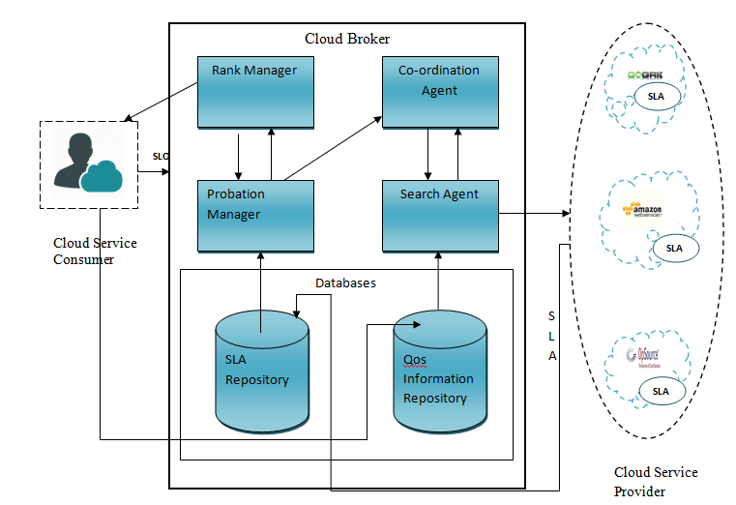

Figure 1: Architecture

The Cloud Broker has two databases SLA repository and Qos information reposi- tory and has probation manager, rank manager, co-ordination Agent and search agent. The SLAs of cloud service providers are stored in the SLA Repository of cloud broker. The SLA document consists of the quantifiable and non- quantifiable Qos parameters which include service name, cloud provider, security, availability, processor speed,
cost per hour, storage, bandwidth, performance, etc.,
The Probation Manager : takes SLA from SLA repository and checks the parameters of SLA during the probation period. After the validation it informs the rank manager with updated parameters.
The Rank Manager: has rank table and updates the rank table with SLA parameter given by probation manager. Rank table contains ranking of cloud services according to the SLA parameters. If a service is longer used by a consumer, then rank manager gives the service to probation manager for validation.
The Qos information repository: feedback of the past customer experience are stored in Qos Information Repository.

6 Modules

1. Build SLA Repository and Design Cloud Broker
- Probation Manager
- Rank Manager
2. Build Qos Information Repository and add into Cloud Broker
- Co-ordination Agent
- Search Agent
3. Integration of cloud service consumers requirements with broker
4. Cloud Service Ranking and Selection using PSO

7 Computing Environment

- Java(JDK 1.7)
- Cloudsim 3.0.3
- Netbeans 8.0.2
8 Implementation

8.1 SLA Repository

Step1: The SLA from cloud service providers for differenet cloud services was col- lected. The SLA document consists of the quantifiable Qos parametersuca as service name,

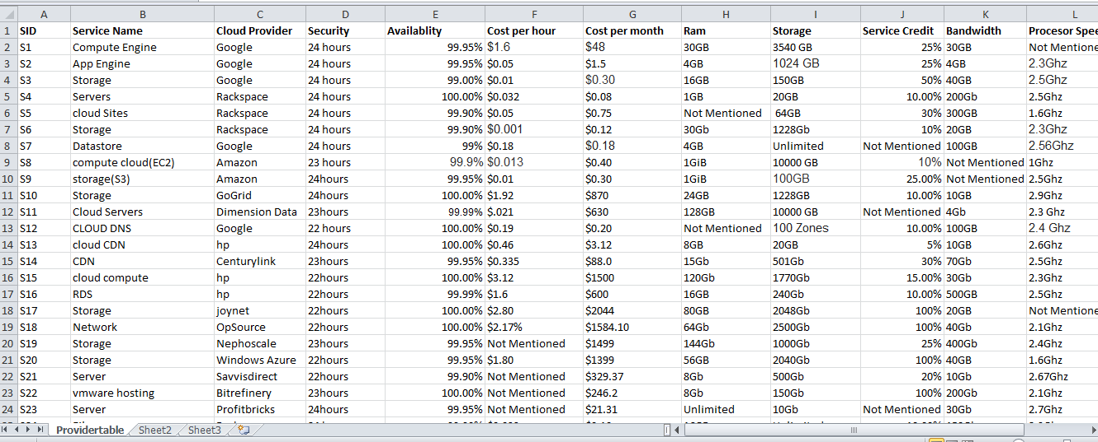

Figure 2: Input SLA

cloud provider, security, availability, processor speed, cost per hour, storage and non Qos parameter as bandwidth etc. The SLA parameters are collected and stored in Mysql server.

8.2 Design of Cloud Broker

The cloud broker has four entities Probation Manager, Rank Manager ,Co-ordination Agent, Search Agent. Using cloudsim, the broker is created with entities along with cloudlets.

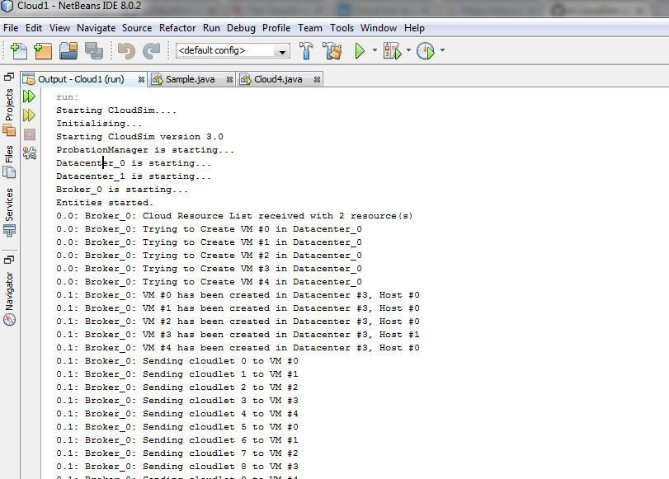

Figure 4: Creation of
8.3 Probation Manager

Step1:Simulation of Probation Manager

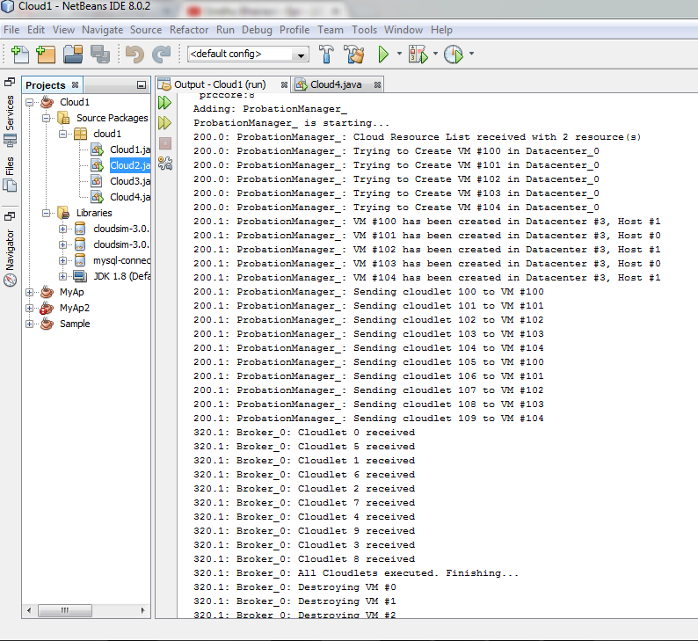

Figure 5: Probation Manager simulation

Step2: The Probation Manager gets the SLA parameters from the database and populate the table with SLA.

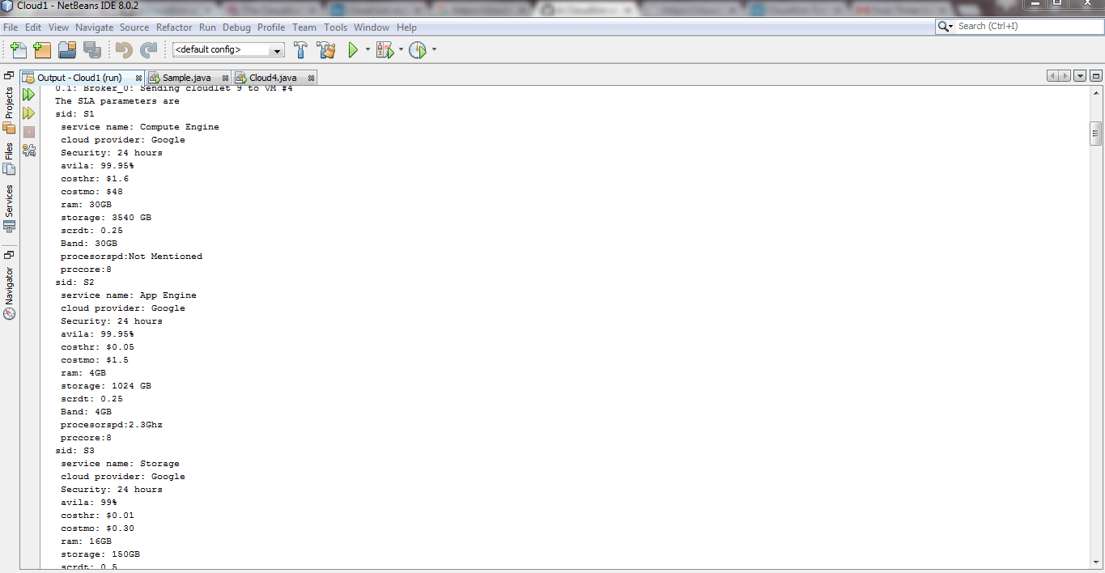

Figure 6: Probation Manager gets SLA’s
9 Timeline

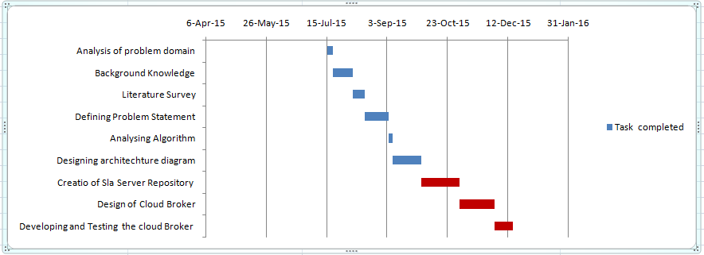

Figure 7: Phase 1

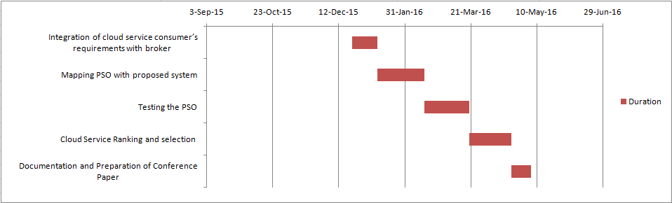

Figure 8: Phase 2
References

